HOW TO install MySQL -- <https://youtu.be/K0evMGWkC0U>

HOW TO SETUP resume Table in MySQL:

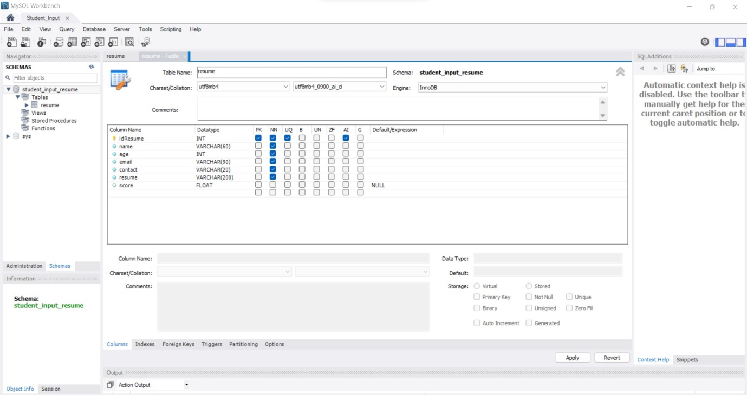

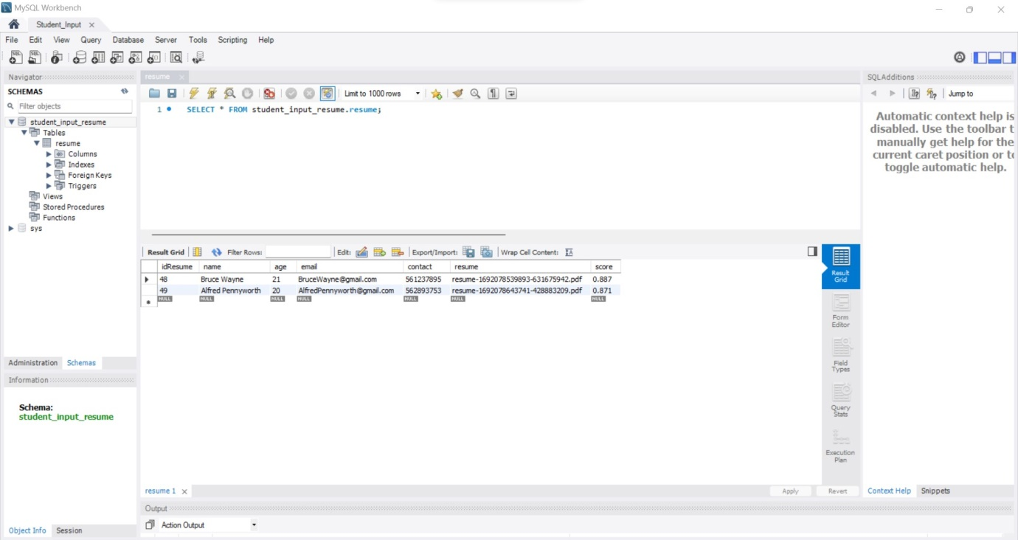

**In Line 88 in file server.js :**

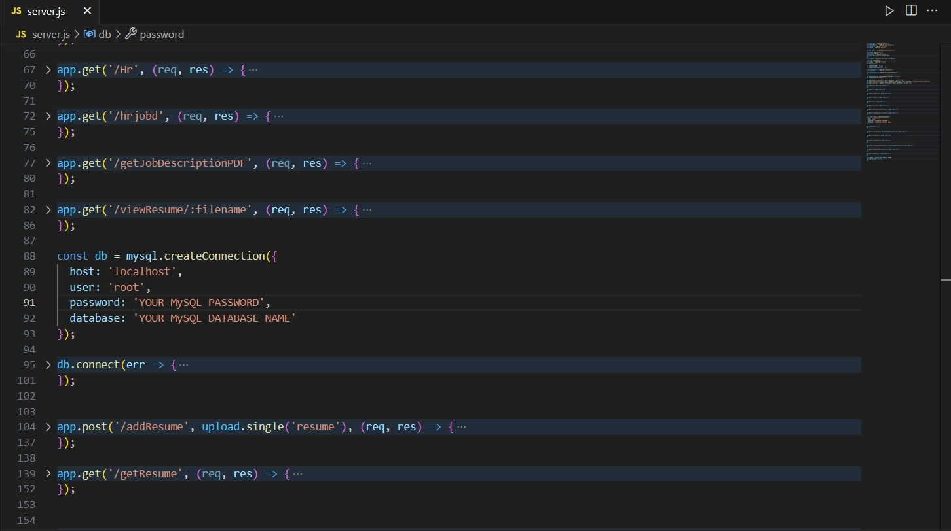

**Update Password and Database Name for your MySQL connection.**